**EMPLOYEE LEAVE MANAGEMENT SYSTEM**

Capstone Project Presented to

CEDAR COLLEGE, Inc.

National Highway

Cadiz City, Negros Occidental

In Partial Fulfillment of the

Requirements for the Degree of

Bachelor of Science in Information Technology

Jessica P. Borromeo

Stephanie Jane M. Cañete

Jude G. Recaña

November 2024

**CHAPTER 1**

**INTRODUCTION**

**Project Context**

In today's fast-paced and highly competitive work environment, effective employee management is vital in ensuring productivity, job satisfaction, and organizational goals. One of the core components of employee management is leave administration. These involve tracking vacation days, management of sick leaves, handling sudden absence, and ensuring adequate manpower. Most organizations still rely on manual record-keeping or spreadsheet systems to manage employee leave, often causing inefficiencies, errors, and communication breakdowns that adversely affect organizational operations.

Employees should have a simple process for requesting leave, whether it is for vacations, emergencies, or personal needs. However, most workplaces are still dominated by manual processes, emails, and paper forms, which create bottlenecks in approvals, missed communications, and confusion over leave balances. This leaves employees uncertain about their leave entitlements, managers struggling to maintain team availability, and HR teams burdened with reconciling records. In today's work environment, efficiency and transparency are essential for fostering trust and smooth operations.

**Project Description**

The Employee Leave Management System (ELMS) is designed to automate and streamline leave management processes. Employees can easily apply for leaves and check their leave balances, while Admin can process and approve requests efficiently. Automated notifications keep everyone informed, and a shared team calendar enables better workforce planning.

To enhance the system, the ELMS incorporates a payroll feature that integrates leave records with employee compensation, ensuring accurate salary computations based on attendance, approved leaves, and other adjustments. By automating these interconnected processes, the system reduces manual errors, improves transparency, and saves time for Admin personnel. With its intuitive interface and robust features, the ELMS simplifies leave management while adding value through payroll integration. Employees gain confidence and convenience in managing their leaves and understanding their compensation, while managers and HR teams benefit from tools that streamline planning and decision-making, fostering a workplace where administrative tasks are efficient and transparent.

**Objectives**

The primary objective of an Employee Leave Management System is to create a streamline and automate the leave request, approval, and tracking process for employees, managers, and HR departments. Furthermore, the specific objectives are as follows:

1. To streamline the leave request and approval process by developing a user-friendly platform for employees to submit leave requests and for managers to review and approve requests efficiently.
2. To enhance transparency and accessibility by enabling employees to view their leave balances, history, and request statuses in real time, fostering trust and clarity in the leave management process.
3. To facilitate effective resource planning and team management by providing managers with a shared calendar or team view of planned absences, aiding in workload management and ensuring adequate team staffing.

**Scope and Limitation**

The ELMS provides a centralized, web-based leave management system to streamline leave request, approval, and tracking processes. The system allows employees to submit leave requests, check their leave balances, and track the status of their applications in real time. Admins will have a view of an integrated calendar showing planned absences by team members, thus allowing efficient resource management and ensuring the appropriate number of staff available. The system also comes with self-updating automated status notice for leave request and generate reports on leave patterns, making Admin decisions on policy changes and resource development.

Despite its comprehensive functionality, the ELMS has certain limitations. While the system includes a payroll feature, it does not support automatic adjustments for unpaid leave or integration with external payroll systems, requiring Admin personnel to perform payroll updates separately. Advanced customizations, such as unique leave policies or organization-specific rules, may necessitate additional development as the system is initially designed to accommodate standard leave policies. Additionally, the system's accuracy depends on correct user input; errors in leave details or approvals must be manually rectified by an Admin or management to maintain data integrity.

**Definition of Terms**

1. **Leave Request**

A formal submission by an employee to take time off from work for personal, medical, or other reasons.

Operationally, in the Employee Leave Management System (ELMS), a leave request is submitted via an online form specifying the type of leave, dates, and reasons for the request.

1. **Leave Approval**

The process by which a manager or supervisor reviews and either accepts or denies an employee’s leave request.

Operationally: In the ELMS, managers approve or deny requests through a digital interface, with automated status updates sent to employees.

1. **Leave Balance**

The total remaining leave days available to an employee within a specified period, as defined by company policy.

Operationally: The leave balance is updated automatically in the ELMS based on approved leave days and is accessible to both employees and managers.

1. **Employee Self-Service**

A system feature allowing employees to independently access and manage their personal leave information.

Operationally: In the ELMS, employees can log in to view leave balances, submit requests, and track the status of their applications.

1. **Absence Management**

Strategies and tools used by organizations to monitor, track, and minimize unscheduled absences.

Operationally: In the ELMS, absence management is supported by reports and analytics that track leave patterns and provide actionable insights.

1. **Team Calendar**

A shared visual tool that displays the planned absences of team members, used to aid in resource planning and workload distribution.

Operationally: In the ELMS, managers can access a calendar showing all team members’ scheduled leaves, enabling effective planning and staffing.

1. **Team Policy Compliance**

Adherence to an organization’s established rules and regulations regarding leave entitlements and usage.

Operationally: The ELMS enforces leave policies automatically, ensuring compliance with company rules during leave requests and approvals.

1. **Automated Notifications**

System-generated alerts or messages sent to inform users about important updates or required actions.

Operationally: Notifications in the ELMS alert employees and managers about leave request submissions, approvals, rejections, or changes.

1. **Data-Driven Decision Making**

The process of using data insights to guide strategies and policies.

Operationally: The ELMS generates reports on leave usage patterns, enabling HR to make informed adjustments to leave policies and resource allocation.

1. **User Role Access**

Permission levels assigned to users in a system, dictating access to specific features and data based on their roles.

Operationally: In the ELMS, user roles (e.g., Employee, Manager, HR) determine accessible features, ensuring data security and functionality appropriate to each role.

1. **Payroll Integration**

The synchronization of leave records with payroll systems to ensure accurate salary calculations.

Operationally: The ELMS uses approved leave data to support payroll adjustments, automating deductions or credits related to leave usage.

1. **Real-Time Updates**

Instantaneous reflection of changes or actions in the system, ensuring up-to-date information for users.

Operationally: In the ELMS, leave balances, request statuses, and notifications are updated in real time, improving transparency and user experience.

1. **Audit Trail**

A chronological record of actions and changes made within the system for accountability and compliance purposes.

Operationally: The ELMS maintains an audit log of all leave requests, approvals, and modifications, accessible to authorized personnel for review.

1. **Custom Leave Types**

Different categories of leave defined based on organizational policies, such as vacation, sick leave, and maternity leave.

Operationally: The ELMS supports customizable leave types, allowing organizations to align the system with their specific policies.

1. **Backup and Recovery**

Processes for securely storing system data and restoring it in case of failure or loss.

Operationally: The ELMS includes automated data backups to ensure data integrity and facilitate recovery in case of technical issues.

**Review of Related Literature**

In the study conducted by *Ahmad, et al.* (2024) explores the development and benefits of an online employee leave application system. Such a system is said to really make the leave management process better, as it improves leave requests and incorporates more transparency in ensuring timely approval workflows. It makes it easier for employees to request leave but also easier for managers to review requests and approve them in a more organized approach toward the management of absence.

Additionally, the system also cuts down on paperwork and the administrative burden by ensuring better planning and decision-making. It thus comes to be accurate with a diminution in errors and supports effective and reliable management of employee leave entitlements because of the automated tracking of leave balances *Ahmad, et al.* (2024).

Similarly, *Alade, et al.* (2020) designing and implementing a web-based system for managing leave, with the aim of making the leave request process more efficient. Modern web technologies such as HTML, CSS, Python, Django, and SQLite are used in the development of this system to automatically track leaves in full or part and authorize them automatically, thus reducing administrative bottlenecks and delays. A key feature of the system is its user-friendly interface, which enables employees to submit leave requests and view balances with ease, while managers can approve or deny requests through the same platform. The system was evaluated for its accuracy, user satisfaction, and ease of use, with positive results indicating its effectiveness.

The study concludes that the WBLMS significantly improves productivity by automating leave processes, reducing manual errors, and cutting processing times. Its implementation has the potential to streamline leave management in organizations, improving both administrative and employee experiences *Alade, et al.* (2020).

Furthermore, *Setiawan, et al.* (2023), discusses the development of a web-based leave management system for PT. Java Pacific. It is a system aimed at streamlining the leave application, which will make it much more efficient and user-friendly. The Rapid Application Development (RAD) method was adopted, which enables fast development and clear requirement specifications in meeting the needs of an organization. The main objective of the system was to make leave management easier for the employees as well as the HR department. It would enable easier submission, approval, and monitoring of leave requests, thereby improving overall organizational efficiency.

It also helps in promoting transparency since it displays data reporting and employee leave tracking. It concludes that upon implementation, this web-based leave management system offers a much more organized and automated way of processing employee absence, lowers administrative workloads, and improves workflow monitoring for PT. Java Pacific *Setiawan, et al.* (2023).

The study of *Adamu* (2021) the article presents an Employee Leave Management System (ELMS) designed to automate and streamline the leave request process in institutions. The traditional method of manual leave applications was inefficient, prone to errors, and required excessive paperwork. This new system, built using web-based technologies like HTML, CSS, JS, MySQL, and PHP, offers a faster, error-free, and more organized way to handle employee leave. The system operates on a three-tier software architecture and allows staff to request leave, track its approval status, and reduce administrative workload. By automating these processes, the ELMS improves efficiency and ensures that staff can request and manage leave in a timely manner.

Additionally, it provides a comprehensive view of leave balances and approvals. This automated system significantly enhances the management of employee leave for both academic and administrative departments. It reduces paperwork, minimizes errors, and simplifies the approval process, leading to improved overall efficiency in institutions *Adamu* (2021).

In the study of *Ramanan* (2021) the Web-Based Leave Management System developed for the University College of Jaffna aims to streamline and automate the existing manual leave management process. Previously, employees filled out paper forms and submitted them for approval, which was time-consuming and prone to errors. The new system allows employees to apply for leave, track their status, and view their leave history, all from a centralized, user-friendly web platform. The administration can generate reports and maintain accurate records of leave, reducing paperwork and improving efficiency. The system includes multiple user roles, such as Admin, Employee, Head of Department (HOD), and Chief Executive Officer (CEO), each with different access and responsibilities. Admin users can manage user profiles, leave types, and departments, while HODs can approve or reject leave requests within their departments *Ramanan* (2021). The CEO has a broader role, overseeing all leave requests across the college. The system is designed to be hierarchical and ensures that all employees can easily apply for leave and monitor the approval process.

With its web-based infrastructure, the system provides a more efficient, secure, and accessible alternative to the paper-based approach. The platform not only automates leave requests but also tracks approvals and generates detailed leave reports. By reducing manual work, it helps improve the overall efficiency of leave management at the University College of Jaffna, contributing to smoother administrative processes and better resource planning *Ramanan* (2021).

In the study of *Anda, et al.* (2021) the article presents a web-based Employee Leave Management System (ELMS) designed for the City Government of Tagaytay to automate and simplify the leave application and approval process. Employees can submit their leave requests through the system, which allows for easy tracking of approval status.

The system aims to reduce manual processing, increase efficiency, and improve communication between employees and managers. By automating the leave management process, it helps eliminate errors, reduce delays, and ensures that leave balances are accurately maintained. This approach not only streamlines operations but also enhances employee satisfaction by providing a transparent and user-friendly platform for managing leave requests.

Similarly, *Fortich, et al.* (2019) developing a Human Resource e-Leave Management System for Holy Name University to improve the efficiency of leave management processes, replacing the manual system. The system incorporates modules for leave applications, balances monitoring, records management, and decision-making tools for HR officers. It streamlines operations, ensures fair leave policy application, and introduces statistical reporting to enhance workforce productivity. Using technologies like PHP, MySQL, and JavaScript, the system meets web usability standards and provides an accessible, error-free solution. The system is designed with user-friendly features that allow employees to apply for, approve, and track leave without administrative delays.

The proposed system also includes a decision support mechanism that aids HR in strategic decision-making by generating detailed reports on leave trends and employee availability. Unlike existing systems at other universities, this system incorporates interactive and graphical reports for improved decision-making, supporting both day-to-day operations and strategic planning. However, the study acknowledges certain limitations, such as excluding certain leave types like Solo Parent Leave, which are still under policy development. The system focuses on core processes like leave applications, balance management, and report generation. It offers several functionalities for HR management, such as managing employee records, adjusting leave credits, and generating detailed statistics and reports for HR officers and university management *Fortich, et al.* (2019).

In the study by Murla et al. (2020), the article examines a school-based payroll system implemented in Nueva Ecija schools to streamline payroll processing and improve accuracy, efficiency, and security. The system uses Microsoft Excel for computations but faces challenges, including time-intensive preparation and technical limitations. Recommendations include adopting a standardized computerized payroll system to enhance accuracy, reduce delays, and generate comprehensive reports. This approach emphasizes the importance of automation and efficiency in financial processes, aligning with similar goals in employee management systems like ELMS.

In the study of *Ong, et al.* (2019) emphasizes the importance of automating HR processes to improve efficiency and employee satisfaction. It highlights the potential benefits of replacing manual leave management with a digital solution. By implementing a system that streamlines leave applications, approvals, and monitoring, your project aligns with the concept of reducing administrative burdens and enhancing transparency.

Furthermore, the paper discusses how technology can support decision-making processes within HR, which ties into your project's objective of providing managers with data-driven insights, such as leave balances and trends. This will allow them to manage workforce availability more effectively. Lastly, the article advocates for systems that are user-friendly, ensuring smooth interactions for both employees and HR staff. This is crucial for your system’s success, as ease of use and accessibility are vital in ensuring employee adoption and engagement with the leave management platform *Ong, et al.* (2019).

The study by *Agripa and Astillero* (2022) is closely related to the concept of an Employee Leave Management System (ELMS) through its emphasis on automation, user-centric design, and operational efficiency. The QR-based attendance system developed for Sorsogon State University demonstrates how automation can simplify traditionally manual processes, such as tracking attendance and calculating leave credits. Similarly, an ELMS automates leave requests, approvals, and balance tracking, reducing the likelihood of errors while enhancing workflow efficiency. Both systems prioritize user-friendliness, ensuring that employees and administrators can easily navigate their features with minimal training. The QR system’s real-time tracking and report generation capabilities align with the expectations for an ELMS, which must provide instant updates on leave balances and application statuses. Additionally, the QR-based solution's cost-effective design highlights the importance of accessibility, a critical factor in deploying ELMS for organizations with limited resources.

The QR system's adaptability, particularly its response to the need for contactless technology during the COVID-19 pandemic, mirrors the flexibility an ELMS should have in accommodating changes like remote work models or evolving organizational policies. Furthermore, the QR system's compliance with institutional protocols resonates with the need for ELMS to adhere to labor laws and corporate leave policies, ensuring fairness and transparency *Agripa and Astillero* (2022).

**References**

• Ahmad, M., Pratama, G. U., Auliana, S., Rohman, A., & Rizki, M. (2024). *Enhancing Leave Management through an Online Employee Leave Application System. ARRUS* Journal of Engineering and Technology, 4(1), 26-36.

Retrieved From: <https://jurnal.ahmar.id/index.php/jetech/article/view/2711/1857>

Date accessed: November 06, 2024

• Alade, S. M., Adejumo, S., & Alade, T. J. *Design and Implementation of a Web Based Leave Management System*.

Retrieved From: <https://d1wqtxts1xzle7.cloudfront.net/91853492/ijcatr1104-libre.pdf?1664704974=&response-content-disposition=inline%3B+filename%3DDesign_and_Implementation_of_a_Web_Based.pdf&Expires=1733704674&Signature=UyU-qKkK-t9rFEOQhNRoNQOnrLW8t-iZNQ7wJcT1uh6sTRukuPQBhtjraz5c-bMxUhdCq~3o3xnzynLjEaNupW9-Yz1hcBMmpyRg3TUBdmgqZYGhyiUHU8fW6Lj2JzbqxD3dvcfCBCxNhTbiQVhANsNifOdOKPxilaYe~SP8v7jMMUY0WMJZDpAWEQCeWW3fqVYOTfZ3hlosZccnSoc7lXYdrW1dIxpyBmWvU4Nx4kIm9ghpO~wdpYlD5zImEX51Bfge2poakfbDXQL9BZeQqco41Q2mP52FzidV8RxbtNxr9od1xD6B~3QlYbuDghJNX1NjUEEv1cTXBHMcg6Enpw__&Key-Pair-Id=APKAJLOHF5GGSLRBV4ZA>

Date Accessed: November 06, 2024

• Setiawan, A., & Sumarno, S. (2023). Web Based Leave Management System (Case Study of PT Java Pacific). Procedia of Engineering and Life Science, 4.

Retrieved From: <https://doi.org/10.21070/pels.v4i0.1434>

Date accessed: November 06, 2024

• Adamu, A. (2020). Employee leave management system. *FUDMA Journal of Sciences*, 4(2), 86-91.

Retrieved From: https://fjs.fudutsinma.edu.ng/index.php/fjs/article/view/162

Date accessed: November 08, 2024

• Ramanan, M. (2021). Web-Based Leave Management System for University College of Jaffna. *Journal of Research in Technology and Engineering*, 2(3), 106-113.

Retrieved From: https://d1wqtxts1xzle7.cloudfront.net/67934489/11_Final-libre.pdf?1625802608=&response-content-disposition=inline%3B+filename%3DWeb_Based_Leave_Management_System_for_Un.pdf&Expires=1733705195&Signature=eT3wv7vtXh2RScWWw3O~ORqy4pw4t-HJYa-tyxuTy-sl2zaolDn8M22E2t7CWYsqBGOyW~MNUQ4Zx54IKm8t4g28sN1EY7vDkunNaPsynjMSt1E~3GXuvrxeD8~FzoSsm6cQ~~1Cz70eDL8LjkbtcbPwwOtfyDD1WOG~DAAmtpoinpR6MDQaLs1m9Cb5p3Kask9JOUfLP6EAuwxejS6SyFCxpWaBBrATI9XqxDLo14Qu2LzRd8R1CxkbvH~ELZV9i0maBvqYQCiJC51zEQrr483hBhKa5TIgfy713gzY1s-aPjKWhpzxlO5H6DAALehno-sQIflqfeW6EC33G05U9A__&Key-Pair-Id=APKAJLOHF5GGSLRBV4ZA

Date accessed: November 10, 2024

• Anda, C. A., Alcala, J. M. J., Coper, J. D., Bayot, R. M., Rodriguez, R. L., & Serrano, E. A. (2022, December). A Web-based Application for Employee's Leave Management System for the City Government of Tagaytay. In *2022 2nd International Conference in Information and Computing Research (iCORE)* (pp. 275-278). IEEE.

Retrieved From: https://ieeexplore.ieee.org/abstract/document/10071664

Date accessed: November 9, 2024

• Fortich, M. S., & Marcial, D. E. (2015). Human Resource E-Leave Management: A Decision Support System. Informatika: Jurnal Teknologi Komputer dan Informatika, 10(2), 66037.

Retrieved From: https://d1wqtxts1xzle7.cloudfront.net/66387612/pdf-libre.pdf?1618989070=&response-content-disposition=inline%3B+filename%3DHuman_Resource_E_Leave_Management_A_Deci.pdf

Date accessed: November 09, 2024

• Murla, J. M. C., Roasa, J. A., Reyes, R. V., De, J. S., & Santos, M. D. (2020). Assessment of School-Based Payroll System: Basis for Enhancement. *Journal of Business and Management*, *1*.

Retrieved From: <https://d1wqtxts1xzle7.cloudfront.net/62446904/26IJELS-101202018-Assessmentof20200323-38742-11thah8-libre.pdf?1585015857=&response-content-disposition=inline%3B+filename%3DAssessment_of_School_Based_Payroll_Syste.pdf&Expires=1733705928&Signature=GkBUdaXHjQQ6pvkhEfBayBZot~tKwSNHdtPWPCWET~n-odGh-4k3sTt06ouwDAh09xK9Zy55u1GVpNKWJ3k039NeP2mCAeFSnddsrI8qDNIAV39VfUjduB-uVB-buRoNDxdvfhS~b3qGni71DeNWZNClnmmOH--ooEnIAtWDnUFe647VUUndfYW1PZaP18UwzN3VGPIcV2cjuZDtSKsPhgYVX5Q4h7gGy1xulsL5OuqdSHg~cqvfEnVI09Z5UhXn~cfC1OvYjm0qo08q3j1buPewSxLBrRrJa8iQWImND3TM7x26RWwBRGWFiyTEnSp~v8F7AOIX5URq7ISr5G6HYA__&Key-Pair-Id=APKAJLOHF5GGSLRBV4ZA>

Date accessed: November 10, 2024

• Ong, J. F. B., Tan, J. M. T., Villareal, R. F. C., & Chiu, J. L. (2019). Impact of quality work life and prosocial motivation on the organizational commitment and turnover intent of public health practitioners. Review of Integrative Business and Economics Research, 8, 24-43.

Retrieved From: <https://buscompress.com/uploads/3/4/9/8/34980536/riber_8-s4_01_k19-140_24-43.pdf>

Date accessed: November 10, 2024

• Pagayonan, S. M. S. (2022). Development of Leave Management Information System. International Journal of Research in Engineering and Science (IJRES), 10(6), 511-516

Retrieved From: https://www.ijres.org/papers/Volume-10/Issue-6/1006511516.pdf

Date accessed: November 11, 2024

• Agripa, D. J. B., & Astillero, S. F. (2022). DEVELOPMENT OF EMPLOYEE ATTENDANCE AND MANAGEMENT SYSTEM USING QUICK RESPONSE (QR) CODE IN SORSOGON STATE UNIVERSITY, CASTILLA CAMPUS, PHILIPPINES. *European Journal of Education Studies*, *9*(11).

Retrieved From: <https://oapub.org/edu/index.php/ejes/article/view/4545>

Date accessed: November 10, 2024

**Conceptual Framework**

**IPO Model**

|  |  |  |
| --- | --- | --- |
| **INPUT** | **PROCESS** | **OUTPUT** |
| • Employee information  • Leave types  • Leave request  • Leave balance  • Employee role access  • Payroll details | • Leave request submission  • Leave validation  • Approval workflow  • Leave record updates  • Real-time notifications  • Leave reports  • Calculate payrolls  • Generate payroll  reports | • Updated leave balances  • Approval status  • Payroll Reports  • Employee satisfaction |

**CHAPTER 2**

**METHODOLOGY**

**Research Design**

This study uses a qualitative approach and a descriptive research design to explore the experiences and challenges of employees and managers at Cedar College Inc. when accessing and utilizing the Employee Leave Management System. The study aims to understand the effectiveness of the system in meeting its objectives, such as streamlining leave requests, managing approvals, and providing access to leave balances. To collect this diverse feedback, the researchers would be using multiple data collection methods in form of interviews, focus groups, and usability assessments. In so doing, it would gather depth insights regarding the ease of filing leaves, approval workflows, and even leave balance information transparencies. The descriptive design of the research will elucidate at great depth how employees and managers interact with the system, in effect showing its effectiveness in the improvement of leave management processes, ensuring transparency, and enhancing resource planning.

**Locale of the Study**

The study will take place at Cedar College Inc. The research will focus on the employees such as teachers and admin who make use of the Employee Leave Management System within the organization. This locale has been chosen due to the active implementation of digital systems, which includes the leave management system that plays a significant role in the day-to-day administrative processes of the institution.

Data gathering for the study will be distributed to a total of 15 respondents through the use of survey questionnaires, where there will be an evaluation of teachers' and admins' experiences, challenges, and perceptions on the system. The survey will be given to participants from all departments: academic, administrative, and support staff, thus giving a full view of how the system works from different roles. Through the use of surveys, the study will capture a wide range of feedback on system features, usability, and impact, thus providing very valuable insights into its effectiveness in streamlining leave management, improving transparency, and aiding resource planning.

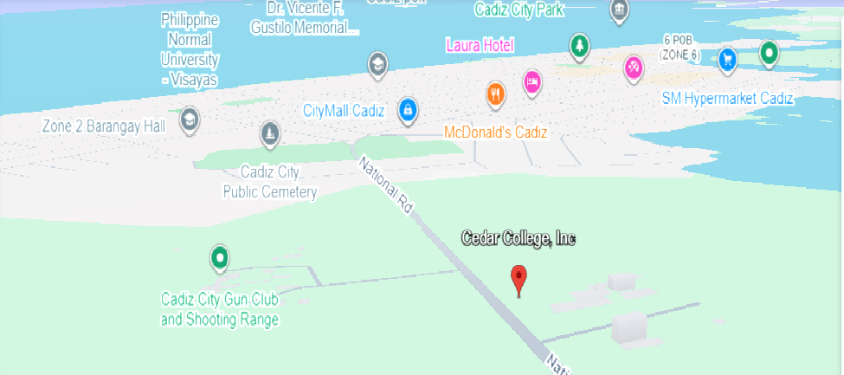

The school is located at National Highway, Cadiz City, Negros Occidental, Visayas, Philippines.

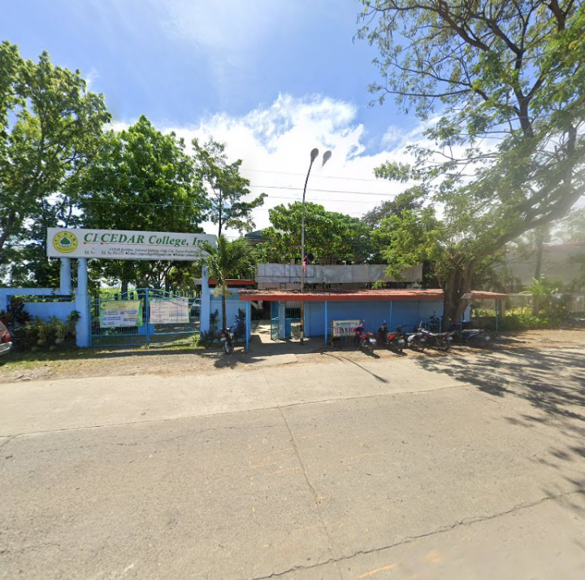

**Theoretical Framework**

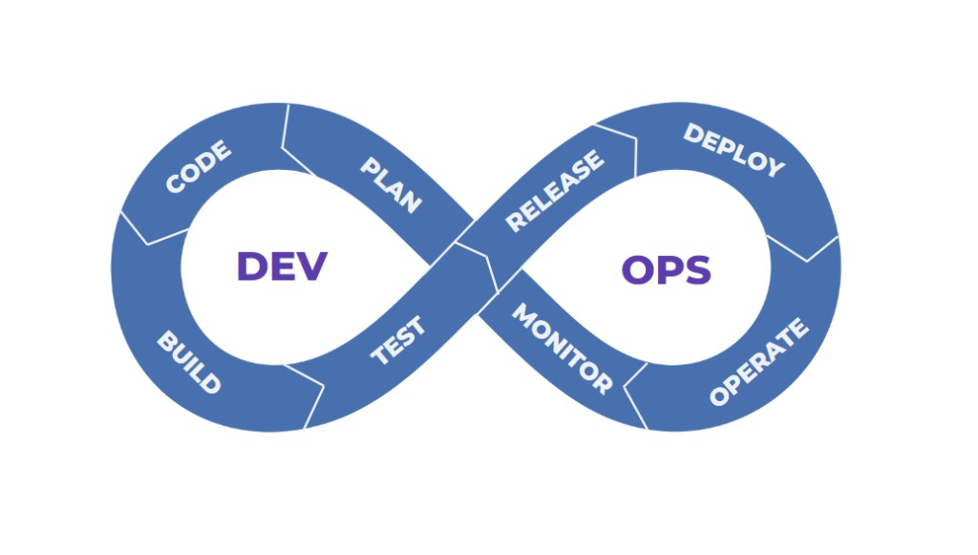

The Employee Leave Management System (ELMS) employs a DevOps approach to enhance reliability, efficiency, and user satisfaction through continuous integration and deployment. By fostering collaboration between admins and employees, ELMS ensures features like leave requests, approval workflows, leave balance tracking, and payroll are seamlessly developed and integrated. Continuous testing and deployment keep the system aligned with organizational needs, minimizing disruptions and enabling rapid updates. Real-time user feedback and automated monitoring address performance issues promptly, ensuring smooth operation. This approach promotes transparency, scalability, and adaptability, optimizing both software development and employee leave management while supporting dynamic organizational requirements.

In the Plan stage, we define project objectives and user requirements to outline system features. Stakeholder meetings help break down complex features into user stories from both employee and admin perspectives. This stage sets a clear roadmap, identifies technical and operational needs, and evaluates potential risks early.

During the Code stage, the development team creates the ELMS and payroll features using clean, modular, and scalable coding practices. Git is used for version control, enabling collaborative development and branch management for features like leave requests and payroll calculations, ensuring code quality and minimal issues.

The Build stage compiles and packages the code into an executable format. CI/CD tools like GitHub Actions automate builds, ensuring early detection of integration issues. Dependencies are managed carefully to ensure the application functions smoothly with required libraries and services.

In the Test stage, we use automated and manual testing strategies to verify system functionality. Tools like Selenium are employed for end-to-end testing, ensuring proper leave processing and payroll calculations. Unit and manual tests cover edge cases, ensuring a defect-free, user-friendly system.

The Release stage prepares the system for deployment by packaging code, configurations, and components. Using a CD pipeline, releases are automated and error-free. Final checks are performed in a controlled environment, and documentation for end users and developers is prepared.

In the Deploy stage, the application is launched in the staging or production environment using tools like Docker for containerization and Kubernetes for orchestration. Deployments are conducted with minimal downtime, using techniques like blue-green deployments to ensure smooth transitions.

The Operate stage focuses on system maintenance, using tools like Terraform for automated server provisioning. Regular updates, patches, and backups ensure stability and scalability to handle increased user loads while maintaining system performance.

In the Monitor stage, real-time performance metrics are tracked using tools like Prometheus or Grafana. Feedback from users and system behavior is used to identify improvements, ensuring the system evolves to meet the organization’s changing needs.

**Use Case Diagram**

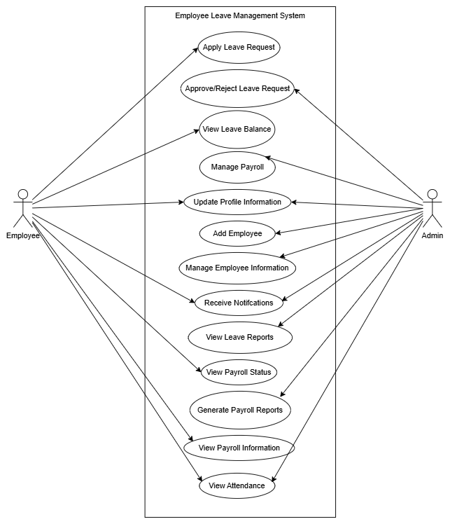

**Requirement Cost**

|  |  |  |
| --- | --- | --- |
| Description | (admin) | (user) |
| I. HARDWARE REQUIREMENTS |  |  |
| • Laptop  • HP ProBook 640 G5  Processor  • Intel® Core(TM) i5-8265U CPU @  1.60GHz, 1800 Mhz, 4 Core(s)  RAM  • 8.00 GB  ROM  • 512 GB SSD  • 512 GB HDD |  | ₱ 18,000 |
| • Desktop Computer  • CPU Type: IntelCore i5  • CPU Model: 12600k | ₱ 13,650 |  |
| • Monitor  • Dell 27 Monitor SE2722H 27″ Full HD  (1080p) 1920 x 1080, 72% sRGB | ₱ 8,030 |  |
| II. SOFTWARE REQUIREMENTS |  |  |
| • Operating System (Windows 10 Home) | ₱ 10,000 |  |
| • Database Software (MySQL version: 10.4.32) | ₱ 0 |  |
| • Version Control (GitHub) | ₱ 0 |  |
| • Testing Tool (Selenium Web Driver) | ₱ 0 |  |
| • IDE (Visual Studio Code) | ₱ 0 |  |
| • Web Browser (Chrome) | ₱ 0 |  |
| III. NETWORK REQUIREMENTS |  |  |
| • 300 Mbps Fiber Plan (per month) | ₱ 1,799 |  |
| • CAT-5e Ethernet Cable (10 m) | ₱ 500 |  |
| IV. INTEGRATION REQUIREMENTS |  |  |
| • Email API (SMTP) | ₱ 0 |  |
| • Domain Name (Namecheap .com Domain)  TOTAL | ₱ 655  ₱ 34,634 | ₱ 18,000 |
| V. LABOR COST |  |  |
| • Programmer (Full Stack) | ₱ 40,000 |  |
| • Maintenance | ₱ 5,000 |  |
| • System Analyst | ₱ 20,000 |  |

**Gantt Chart**

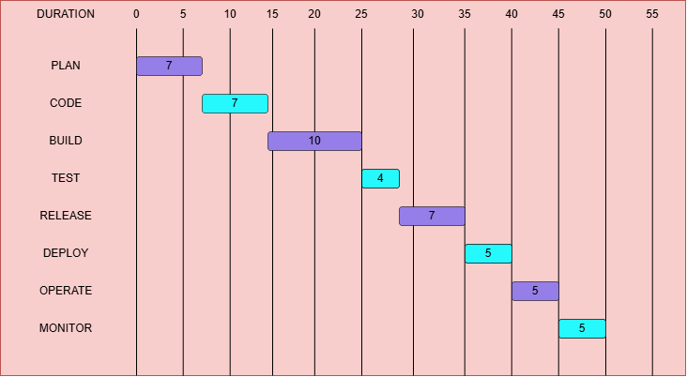

**System Prototype**

The first page before the users logs in or sign up to the system.

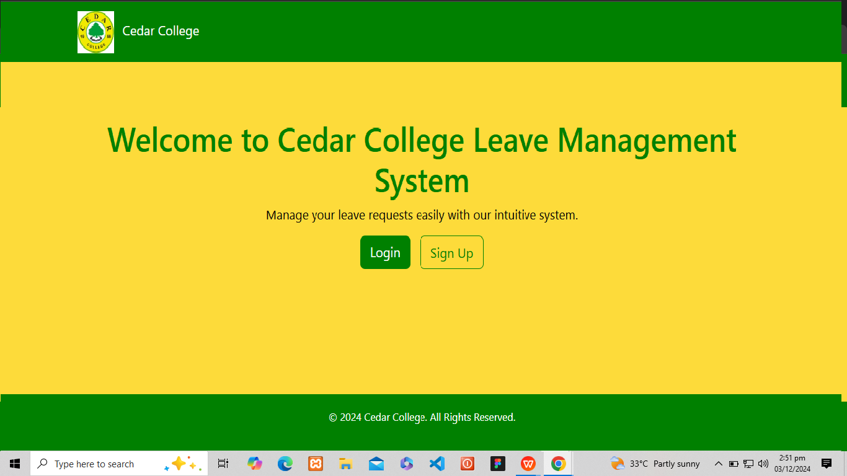

The second page is where the user signs up to the system.

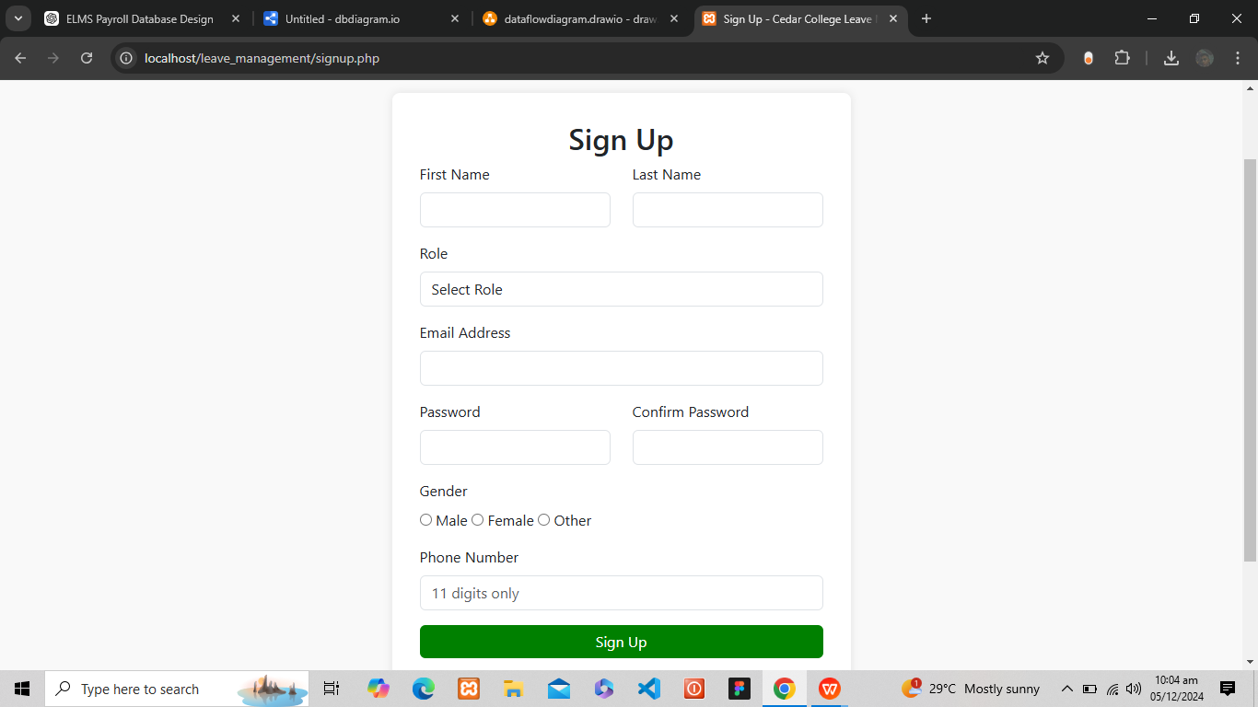

The third page where the user logs in to the system.

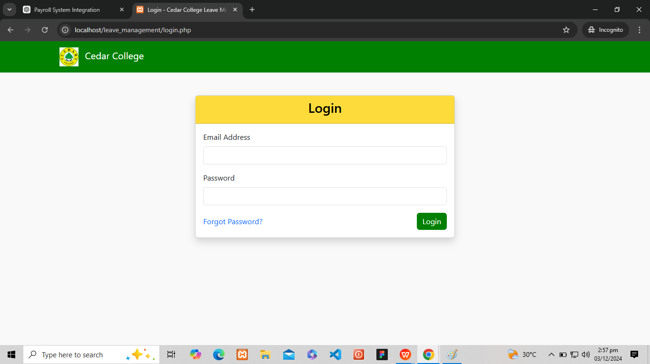

**Data Flow Diagram**

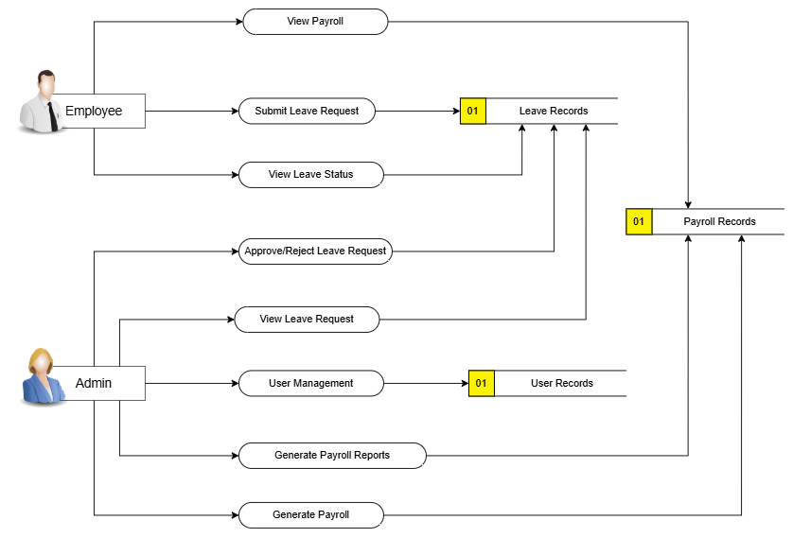

**Data Flow Diagram Level 0**

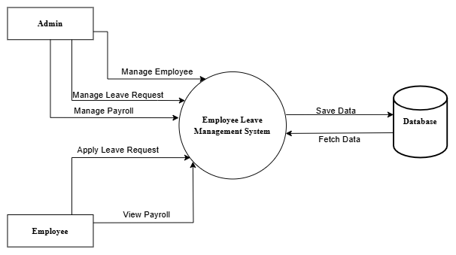

**ER Diagram**

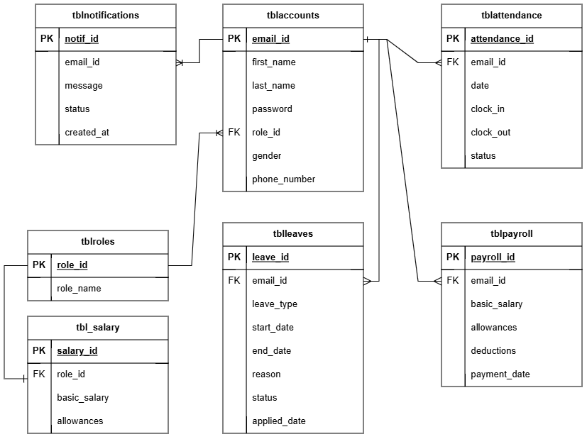

**System Architecture**

The architecture for our Employee Leave Management System (ELMS) adopts a layered approach to streamline functionality and enhance user experience. It features a responsive interface that enables employees to effortlessly submit leave requests, view leave balances, and track request status in real time. In addition to leave management, employees can access their payroll information, including salary details, and deductions directly from the system. Admins benefit from an intuitive dashboard that allows them to review and approve leave requests, while also gaining insights into their team's attendance and leave patterns. The dashboard includes a shared team calendar for effective resource planning and ensures payroll data is synchronized with leave balances, making the payroll process more efficient.

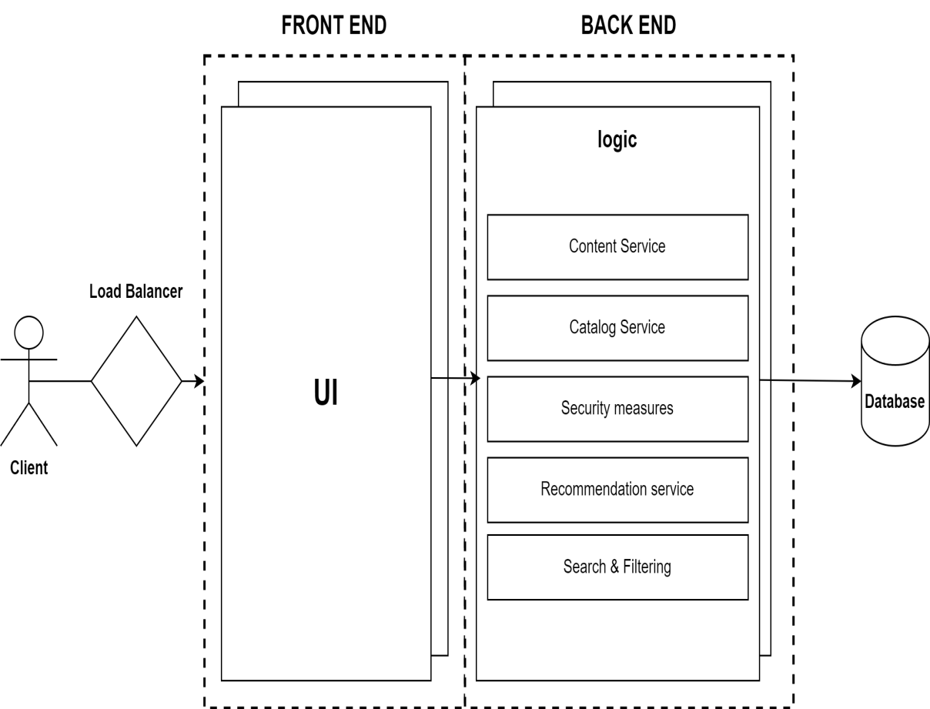

**PERT**

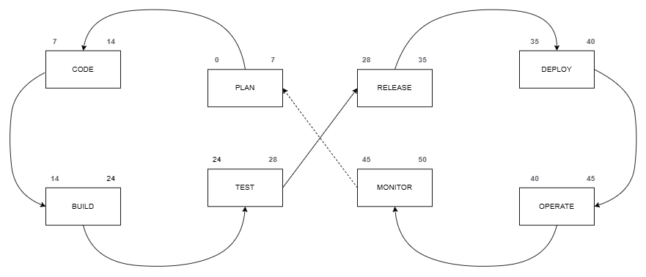

**CPM**

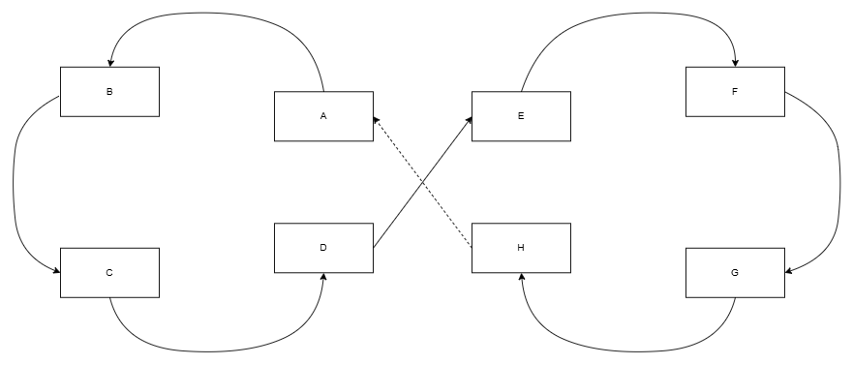

Total No. of Days: 50 days

Critical Path: A, B, C, D, E, F, G, H

**COST-BENEFIT ANALYSIS**

|  |  |  |  |  |  |  |  |  |
| --- | --- | --- | --- | --- | --- | --- | --- | --- |
| ITEM | Year 0 | Year 1 | Year 2 | Year 3 | Year 4 | Total Cost | Total Benefits | Net Benefit/Cost |
| Development Cost | ₱114,680 | - | - | - | - | ₱114,680 | - | - |
| Operational Cost | - | ₱29,948 | ₱29,448 | ₱29,448 | ₱29,448 | ₱118,292 | - | - |
| Maintenance Cost | - | ₱5,000 | ₱5,000 | ₱5,000 | ₱5,000 | ₱20,000 | - | - |
| **Total Cost** | **₱114,680** | **₱34,948** | **₱34,448** | **₱34,448** | **₱34,448** | **₱252,972** | - | - |
| PV Factor (10%) | 1.000 | 0.909 | 0.826 | 0.751 | 0.683 | - | - | - |
| Present Value | ₱114,680 | ₱31,768 | ₱28,454 | ₱25,870 | ₱23,528 | - | ₱224,300 | - |
| **TOTAL BENEFITS** | **-** | **₱ 80,000** | **₱ 85,000** | **₱ 95,000** | **₱ 105,000** | **₱ 365,000** | - | - |
| PV Factor (10%) | 1.000 | 0.909 | 0.826 | 0.751 | 0.683 | - | - | - |
| Present Value | ₱0 | ₱72,720 | ₱70,210 | ₱71,345 | ₱71,715 | - | ₱285,990 | - |
| Net Cash Flow | -₱114,680 | ₱40,952 | ₱41,756 | ₱45,475 | ₱48,187 | - | ₱61,690 | ₱61,690 |

**ROI**

Present Value Benefits ₱ 285,990

Initial Value Cost ₱ 224,300

Formula for Calculating the ROI:







ROI% = 0.2438 x 100

27.50%

Return of Investment =

**CHAPTER 3**

**FINDINGS AND PROJECTIONS**

A survey was conducted as part of the requirements gathering phase for developing an Employee Leave Management System, designed to streamline the leave request and approval process, enhance transparency in leave tracking, and facilitate effective resource planning and team management. The system aims to provide employees with an easy-to-use platform for submitting and tracking leave requests, while offering managers a tool to efficiently review and approve these requests.

The survey was distributed to 15 respondents, consisting of 10 males (66.67%) and 5 females (33.33%).

The questions were designed following the ISO/IEC 9126 standard, and the responses were collected using a Likert Scale with options: Strongly Agree, Agree, Neutral, Disagree, and Strongly Disagree.

**Figure 1. Survey Responses on Meeting Necessary Functional Requirements**

As shown in the figure above, the majority of respondents (12 out of 15, or 80%) either agreed (6 respondents, or 40%) or strongly agreed (6 respondents, or 40%) that the system must meet all necessary functional requirements. A significant portion (3 respondents, or 20%) selected neutral, indicating some uncertainty or indecision about this requirement.

The results suggest a strong emphasis on the importance of functional requirements, reinforcing the system's potential to meet user expectations upon implementation.

**Figure 2. Survey Responses on Ease of Submitting Leave Requests**

As shown in the figure above, 66.67% of respondents agreed or strongly agreed that the system should allow employees to easily submit leave requests, with 33.33% neutral. No respondents disagreed, indicating strong support for this feature.

These responses highlight the importance of simplicity and accessibility in submitting leave requests, suggesting its significance for system usability.

**Figure 3. Survey Responses on Accurate Leave Balance Tracking**

As shown in the figure above, 60% of respondents agreed or strongly agreed that the system should accurately track and display leave balances, with 33.33% neutral and 6.67% disagreeing.

The responses indicate general support for accurate leave tracking, though some mixed opinions suggest room for further clarification or improvement.

**Figure 4. Survey Responses on System Reliability**

As shown in the figure above, 80% of respondents agreed or strongly agreed that the system should be reliable and experience minimal downtime, with 20% neutral. No respondents disagreed, emphasizing the critical need for system reliability.

The responses underscore reliability as a fundamental requirement, essential for user confidence in the system.

**Figure 5. Survey Responses on Error-Free Leave Request Processing**

As shown in the figure above, 66.67% of respondents agreed or strongly agreed that the system should process leave requests without errors, with 33.33% neutral. No respondents disagreed, showing strong support for error-free functionality.

The feedback highlights the importance of accuracy in leave request processing to maintain trust and efficiency.

**Figure 6. Survey Responses on Accurate Notifications**

As shown in the figure above, 66.67% of respondents agreed or strongly agreed that the system should provide accurate notifications for leave approvals or denials, with 33.33% neutral. No respondents disagreed, suggesting this feature is generally seen as essential.

The results emphasize the role of accurate notifications in streamlining the leave approval process and keeping users informed.

**Figure 7. Survey Responses on Intuitive and Easy-to-Navigate UI**

As shown in the figure above, 53.33% of respondents agreed or strongly agreed that the system’s user interface is intuitive and easy to navigate, with 46.67% neutral. No respondents disagreed, reflecting moderate support for an easy-to-use UI.

The responses suggest mixed opinions, indicating that additional testing may be needed to enhance the system's usability.

**Figure 8. Survey Responses on Ease of Finding Leave-Related Information**

As shown in the figure above, 66.67% of respondents agreed or strongly agreed that the system should enable employees to easily find leave-related information, with 33.33% neutral. No respondents disagreed, highlighting the feature's perceived importance.

The responses indicate that easy access to leave-related information is a key factor in user satisfaction and system effectiveness.

**Figure 9. Survey Responses on Straightforward Leave Request Process**

As shown in the figure above, 80% of respondents agreed or strongly agreed that submitting and tracking leave requests should be straightforward. No respondents disagreed, with 20% neutral, indicating strong support for a clear and simple process.

The results suggest that streamlining the leave request process is critical for overall system success.

**Figure 10. Survey Responses on Quick Response to Leave Requests**

As shown in the figure above, 66.67% of respondents agreed or strongly agreed that the system should respond quickly to leave requests, with 33.33% neutral. No respondents disagreed, showing support for efficient processing times.

The feedback indicates that quick responses are essential to meeting user expectations and enhancing productivity.

**Figure 11. Survey Responses on Efficient Leave Request Approval**

As shown in the figure above, 66.67% of respondents agreed or strongly agreed that the system should allow managers to approve leave requests efficiently, with 33.33% neutral. No respondents disagreed, indicating general agreement on the importance of efficiency.

The results highlight the need for a smooth approval process to ensure timely decision-making and satisfaction.

**Figure 12. Survey Responses on Minimal Processing Time**

As shown in the figure above, 66.67% of respondents agreed or strongly agreed that the system should process leave requests with minimal delay, with 33.33% neutral. No respondents disagreed, showing support for timely processing.

The responses emphasize the importance of efficiency in handling leave requests to maintain user satisfaction.

**Figure 13. Survey Responses on Ease of Updating or Modifying the System**

As shown in the figure above, 80% of respondents agreed or strongly agreed that the system should be easy to update or modify, with 20% neutral. No respondents disagreed, indicating strong support for system flexibility.

The results suggest that adaptability for future updates is a valued feature among users.

**Figure 14. Survey Responses on Ease of Maintenance Over Time**

As shown in the figure above, 66.67% of respondents agreed or strongly agreed that the system should ensure ease of maintenance over time, with 33.33% neutral. No respondents disagreed, reflecting moderate confidence in long-term maintainability.

The feedback highlights the need for a design that facilitates simple and efficient maintenance.

**Figure 15. Survey Responses on Resolving System Issues**

As shown in the figure above, 26.67% of respondents agreed or strongly agreed that resolving system issues should be easy, with 66.67% neutral. No respondents disagreed, indicating some uncertainty but recognizing the importance of issue resolution.

The responses suggest that system reliability and troubleshooting capabilities will be critical to user satisfaction.

**Recommendation**

For the Employee Leave Management System, it is recommended to design a user-friendly platform that simplifies the leave request and approval process for both employees and administrators. The system should feature clear navigation and be responsive across various devices, ensuring accessibility for all users. Additionally, employees should have easy access to their leave balances, history, and policies, while managers can efficiently review and approve leave requests. Integrating automated notifications for leave updates will help keep everyone informed in real time.

A key enhancement for the system would be its integration with payroll systems. By automatically calculating salary adjustments based on leave taken, this integration will ensure employees are compensated accurately for their time off. It will also simplify payroll processes by eliminating the need for manual leave tracking, reducing errors and improving efficiency. Managers will benefit from having a clear overview of leave data alongside payroll, streamlining administrative tasks.

To optimize efficiency, the system should include a shared calendar for managers to view and manage team absences. This will help prevent staffing shortages and allow for better planning. The inclusion of real-time dashboards will provide managers with insights into leave trends and patterns, helping them make informed decisions. Additionally, the system should be quick to process leave requests to avoid delays and ensure a smooth workflow.

Finally, the system should prioritize security and reliability. Implementing features like two-factor authentication and data encryption will safeguard sensitive employee information. Regular updates and scalability will ensure the system remains functional as the organization grows, while a robust backup and recovery system will protect data integrity. By focusing on these areas, the system will improve both employee satisfaction and administrative efficiency.

**CHAPTER 4**

**CONCLUSION AND RECOMMENDATIONS**

**CONCLUSION**

The Employee Leave Management System (ELMS) represents a significant improvement over traditional leave management practices by offering a streamlined, automated, and accessible platform for both employees and administrators. By enabling employees to submit leave requests, track their leave balances, and view approval statuses, the system ensures greater transparency and efficiency in managing employee time off. With features like real-time notifications, customizable leave policies, and integration with the payroll system, the ELMS provides a comprehensive solution that addresses the complexities of managing employee absences. Positive feedback from surveys shows a high level of confidence in the system's functionality, with users appreciating its user-friendly interface and efficient leave approval process. The integration of the payroll system is also seen as a valuable addition, ensuring accurate compensation for time off.

However, to ensure the long-term success and reliability of the system, it is crucial to focus on maintaining its technical stability, scalability, and user support. The system must be able to handle increasing amounts of data as the organization grows and provide continuous updates to adapt to any changes in leave policies or payroll requirements. Additionally, ensuring the system’s security with measures like data encryption and two-factor authentication will be vital in protecting sensitive employee information.

**RECOMMENDATION**

To maximize the effectiveness of the Employee Leave Management System, it is recommended to focus on refining the user interface for greater accessibility, ensuring employees can easily navigate the platform and managers can quickly approve or reject leave requests. Customizable workflows should be prioritized to accommodate the specific needs of different departments and organizations. The system should also be optimized for use across various devices, ensuring accessibility from anywhere at any time.

The payroll integration feature should be further enhanced to automate the adjustment of salaries based on leave taken, thus minimizing manual errors and improving payroll accuracy. It is also recommended to implement regular updates to ensure the system remains scalable, functional, and relevant to the evolving needs of the organization. To improve user engagement, adding features like the ability to save or bookmark frequently used leave requests and making leave balance information easily accessible will enhance overall usability.

Finally, user training and ongoing support are essential to ensure employees and managers can fully leverage the system's features. Gathering continuous feedback from both employees and administrators will allow for the continuous improvement of the system. Collaboration with IT professionals for technical support and regular system evaluations will help maintain the system’s performance and ensure its alignment with organizational goals.